**Future GeoEnergy Resources – PGGE11225**

**Week 3 Practical – Geothermal Energy Resources**

**Dr. Chris McDermott**

Not all the equations you need are given, you will also have to draw on previous science experience (or the internet!) to help you work out the answers.

The Energy E in joules required to heat // cool a fluid can be expressed as



Where:

Cp is the specific heat capacity (isobaric)

 is the density of the fluid

V is the volume of the fluid

 is the change in temperature



**1. How much area is required to boil a kettle?**

My kettle holds 2 litres of water. The geothermal heat flow where we live is 65mW/m2. If I want my kettle to heat water from 20 °C to 100 °C (no steam) in 2 minutes using electricity, over how large an area will I have to capture all the heat flow from the Earth’s surface? Assume the efficiency of turning heat to electricity is 10%, and the efficiency of the kettle is 90%.

(Cpw) Heat Capacity of Water 4180 J/Kg/°C

|  |  |
| --- | --- |
| **Work out heat energy needed (HEN): $$HEN= \frac{C_{p}×ρ×V×∆T}{Kettle efficiency}$$ $$HEN= \frac{4180×1000×0.002×80}{0.9}$$**  HEN = 7.4x105 J  *\*\*(2 litres = 0.002m3)* | **Energy present: $$Energy present=flux×time×efficiency$$ $$Energy present=0.065 ×120 x 0.1$$**  Energy present = 0.78 J/m2  Area required = HEN / energy present $$Area required= {HEN}/{energy present}$$ $$Area required=\frac{{7.4e}^{5}}{0.75}$$ Area = 952,707 m2  **Area = ~1 km2**  i.e. around 5 x area of KB |

**2. Calculate the typical specific heat capacity, heat conductivity and density of saturated sandstone given the following values**

-> This calculation requires the use of equations and relationships given on p7 of this document and the constants provided below:

(λw)Thermal conductivity of water 0.6w/mK

(ρw) Density of Water 1000 Kg/m3

(Cpr) Heat capacity of quartz 1000 J/Kg

(λr) Thermal conductivity quartz 3.0 w/mK

(ρr) Density of quartz 2650 kg/m3

(ne) Porosity of Sandstone 20%

|  |  |  |
| --- | --- | --- |
| Heat conductivity | Specific heat capacity | Density |
| $$λ_{m}=n_{e}λ_{w}+\left(1-n_{e}\right)λ_{r}$$ $$λ_{m}=0.2×0.6+\left(0.8\right)×3$$ $$λ_{m}=2.52 w/mK$$ | $$C_{pm}=n_{e}C_{pw}+\left(1-n_{e}\right)C_{pr}$$ $$C_{pm}=0.2×4180+\left(0.8\right)×1000$$ $$C_{pm}=1636 J/Kg$$ | $$ρ_{m}=n_{e}ρ_{w}+\left(1-n_{e}\right)ρ_{r}$$ $$ρ_{m}=0.2×1000+\left(0.8\right)×2650$$ $$ρ_{m}=2320 Kg/m^{3}$$ |

**3. The artificial heat exchanger** in a Hot Dry Rock reservoir in the above sandstone is estimated to have the dimensions of 1 km x 500 m x 500 m. The current temperature of the reservoir is 150 °C, calculate how much heat can be extracted if the temperature were to be cooled to 100 °C.

Volume = 1000 x 500 x 500 = 250,000,000m2

**Energy = 4.74x1016 J**

**4. If the heat conductivity** of the sandstone is 3.2 (J/K m s) and that of the fluid is 0.6 (J/K m s), the heat dispersion coefficient 0.01 m and the filtration velocity , calculate the heat dispersion diffusion tensor in the longitudinal and transverse directions. Present the result as a tensor.

-> The answer requires the use of relationships presented on p9 of this document

**5. What is heat mining?**

**6. Given the hydrogeological and heat transport characteristics expected in typical overburden rocks illustrated in the diagram below, sketch conceptually a possible heat profile and describe the processes effecting the gradient of the heat profile.**

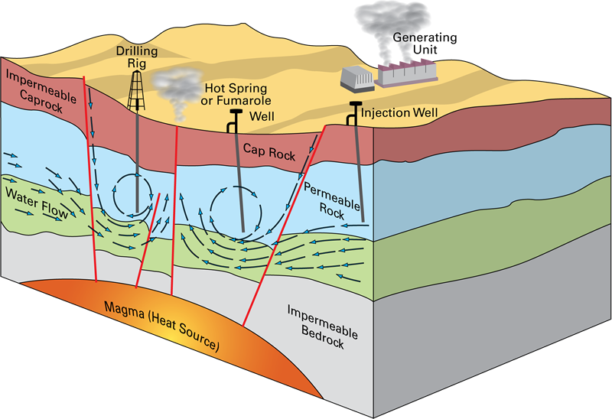

**Review the following proposal and calculations, and critic the methodology**

**Initial Brief // Introduction**

ACF (an Advanced Computer Facility) are looking into ways to dissipate their heat load of around 10 MW at Easter Bush, whilst maintaining a relatively low carbon footprint. One of the possibilities considered was the use of disused coal mine workings known to underlie parts of the Easter Bush site, as a heat store and potential source of heat for other users. The priority is to remove heat from the ACF facility.

The design criteria are such that water is taken into the ACF facility cooling systems at 25 °C, and is expelled at up to 45 °C. This represents a flow rate of ~120 l/s being cooled from 45 °C to 25 °C.

A heat exchanger at the surface is envisaged transferring the heat energy from the ACF closed loop cooling system, to an extraction injection scheme within the coal mine. It is likely that multiple levels and locations of injection and extraction will be necessary to ensure a longer term sustainable heat resource.

**Initial Feasibility, and Key Areas of Investigation**

As a quick “back of the envelope calculation”, assuming that cooling of 20 °C is to be provided at the rate of 110 l/s, and that the water instantly heats the rock whilst losing its own heat (injection at a different location from cool water extraction) it can be shown that the heat can theoretically be stored in a surface footprint area of 3km x 3km, and a strata thickness of 100m operationally for over 100 years-> Do your own calculations to show if this is true.



Geology is heterogeneous. Heat travels both convectively with water flow preferentially through high permeability pathways, and diffusively through solid rock. Mine workings allow hot water to be distributed rapidly over wide areas, but may lead to zones of the rock being totally by-passed during flow. To validate the possibility of heat storage and the zone it will influence it is therefore necessary to get a reasonable understanding of the geometry of the mine workings, the nature of the previous mining and the possible fluid injection and extraction points.

**Imagine you are a company manager, what resources and what skill sets would you assign to undertake a feasibility study, and what time spans for the work.**

-> Access//reproduce available mine working plans to determine the location and extent of any existing workings. Determine geometry and type of workings *(who, ? weeks)*

-> Review technologies used to access heat and store heat in mine workings *(who, ? weeks)*

-> Provide an overview of the key controls of the hydrogeological situation of the mine workings, and any possible background flow direction *(who, ? weeks)*

-> Identify possible interconnection with surrounding mine workings, and consider the problem of groundwater rebound in the Midlothian mine workings area *(who, ? weeks)*

-> Sketch out the possible foot print of the subsurface heat exchange system *(who, ? weeks)*

-> Discuss the principals of regulation with SEPA and the Coal Authority *(who, ? weeks)*

-> Construct a representative 3D numerical model of heat injection from a representation of the mine workings to improve initial scoping calculations Identify likely temperature changes. Show necessary geometrical relationships between injection and extraction locations *(who, ? weeks)*

**Longer term**

-> Design a system of fluid injection and fluid extraction to maximise the possible heat storage

*(who, ? weeks)*

-> Determine the groundwater and mine water geochemistry, and possible impact on plant design *(who, ? weeks)*

**Research//Teaching Opportunity**

Such a facility would also provide a unique opportunity to progress the use of the subsurface in general for heat storage and extraction. This would be of extreme importance to the UK geothermal industry, and could provide a significant facility in terms of both furthering research in this area and demonstrating new technologies. There is already a recent focus on research into the use of heat from coal mine workings, see the formation of the Glasgow Geological Observatory, and such a facility could be expected to attract significant research and industry funding.

-> Provide design options for creating a monitoring system to further the understanding of heat transport and storage in near surface coal mines.

-> Provide a unique resource for teaching GeoEnergy masters students // PhD students, and a field study site for international cooperation.

**What else could it contribute to?**

**What is missing?**

## Mathematical Model of Heat Transport

THIS IS PROVIDED AS REFERENCE ONLY, YOU WILL BE TAUGHT THIS IN HYDRO2

Mathematical models of heat transport are based on the principle of energy conservation. Applying this to the control volume



Control volume (3D flow)

a transport model equation for heat flow can be derived. First, let us consider the energy stored in the control volume. The energy equals  where T is temperature in Kelvin of the porous media (rock) and fluid, ****is the heat capacity of the fluid in the pores,  is the density of the fluid in the pores,  is the heat capacity of the rock, and  is the density of the rock. Therefore, the total energy in the control volume is 

If we express this in terms of the porous medium using the subsymbol ****to represent a medium property then 

the energy in the control volume is then 

Next, heat transport through the vertical faces of the control volume is considered. As heat is transported due to both advection and dispersion/conductance, there are two terms contributing to the energy flux F [M/(L2T)] which is given by



Where is the porous medium heat conductance . Again the subscripts w and r referring to water (or pore fluid) and rock.

In the flux equation the first term represents the advective energy flux while the second term stands for the conductive/dispersive energy flux. Note the similarity to mass transport. The conductive flux is proportional to the temperature gradient (Fickian diffusion). The negative sign indicates that the conductive flux is oriented towards decreasing temperature values.

Following the derivation of the mass transport equation, let *Fx* and  denote energy fluxes through faces normal to the x-axis. By employing this notation it is implicitly assumed that the energy flux changes linearly along *Δx*. This approximation is justified for sufficiently small control volumes.

The net energy flux parallel to the x-axis is therefore given by  . Similarly, the net flux through the control volume parallel to the y-axis equals  and likewise for the z direction.

Consequently, the net energy being transported through the faces of the control volume within the time interval *Δt* is given by .

If there are no sources or sinks, the temporal change of energy in the control volume within the time interval *Δt* is the same as the energy passing through the control volume. Therefore, we have the energy balance

 = or



Sources/sinks may occur due to addition or removal of energy, and can be expressed as a source term. The amount of energy removed or added to the control volume during Δt, equals  where q denotes joules per second of injected/withdrawn energy.



Dividing by ΔxΔyΔzΔt and letting Δt→0, i.e. a point in time one obtains



where the definition of the divergence operator in a 3D Cartesian co-ordinate system has been used. Using  we can now write



This equation is given in terms of energy. Dividing by, and assuming constant material properties we can write



Where the units are temperature in degrees Kelvin.

Here the heat diffusion dispersion tensor D contains a component for pure heat conduction/diffusion, and a component for dispersion due to advection. D is the effective heat diffusion dispersion coefficient in the  direction (J /°Kms), (de Marsily, 1986),  is the advective flow velocity in the  direction (m/s) and  is the heat dispersion coefficient (J / °K m ) in the  direction.



Where for comparison to the mass transport

****(here i represents direction)



For 1D transport (grad = ****, div = ****) without a source term, the aquifer is homogeneous and flow is uniform (v = const., D = const.). the equation reduces to

